IB Chemistry SL
Topic 6 Questions
1. Identical pieces of calcium carbonate are added to two separate flasks containing excess 0.1 mol dm^{–3} hydrochloric acid at different temperatures. The masses of the contents of the flasks are monitored. Which graph represents the reaction at the higher temperature?
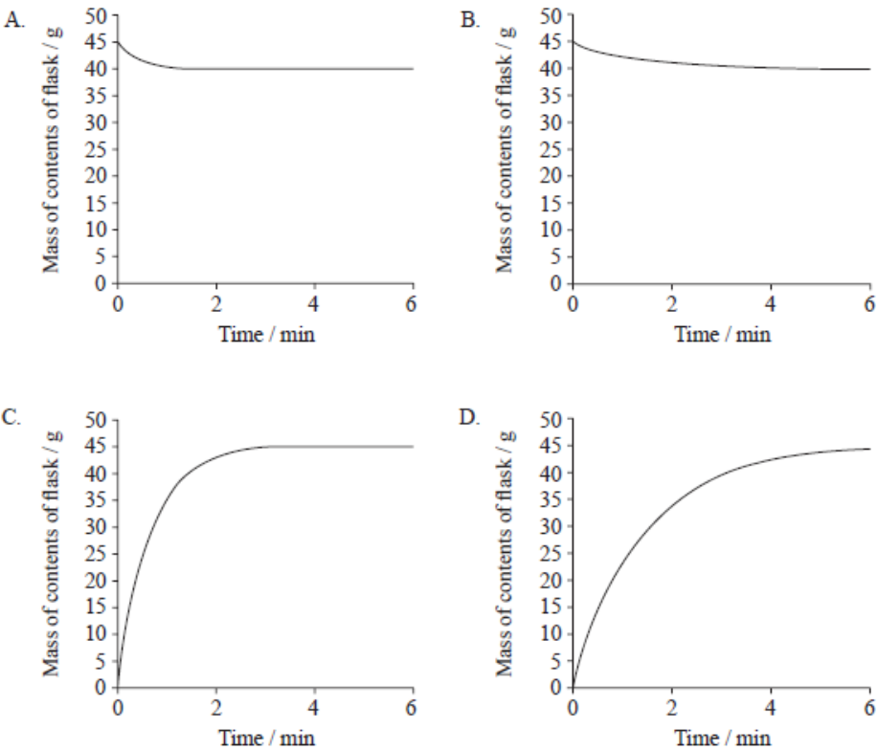
2. Which are appropriate units for the rate of a reaction?
A. mol dm⁻³ s⁻¹ B. mol dm⁻³ s C. mol dm⁻³ D. s
3. Which graph best represents the relationship between the average kinetic energy of molecules of a gas and temperature in K?
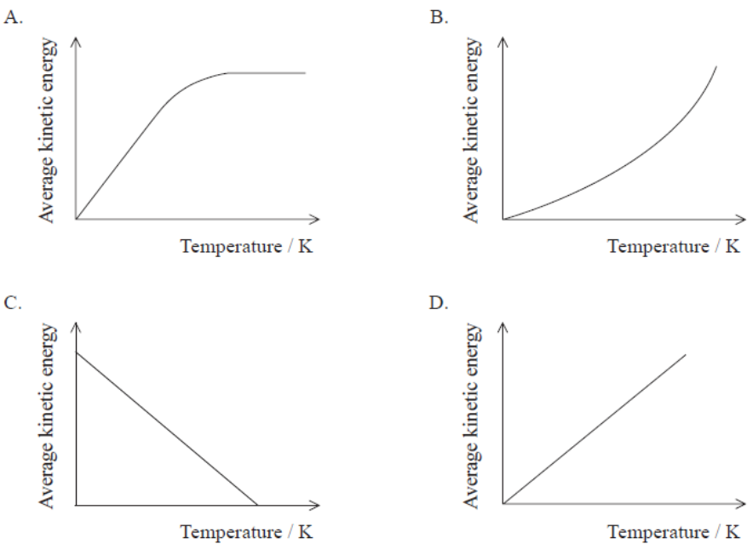
4. The Maxwell–Boltzmann curve below shows the distribution of kinetic energies for the particles in a sample of gas.
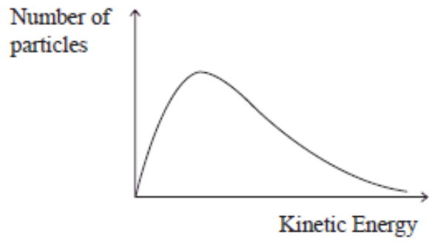
Which is the shape of the curve for the same sample of gas at a higher temperature? All graphs are drawn to the same scale.
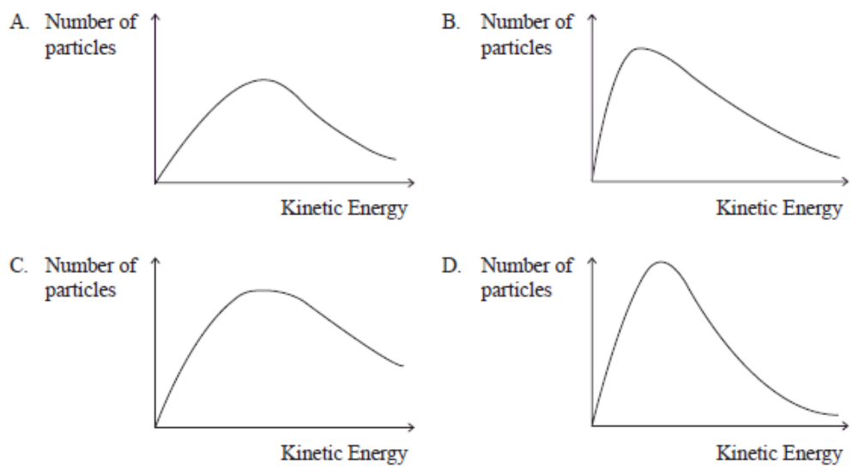
5. Which statement best describes and explains the effect of a catalyst on the rate of a chemical reaction?
A. The rate increases because the frequency of collisions between particles increases.
B. The rate increases because more colliding particles have the energy needed to react.
C. The rate increases because the activation energy increases.
D. The rate increases because more molecules are present.
6. Which statements explain the increase in the rate of a reaction when the temperature is increased?
I. More particles have energy greater than the activation energy.
II. The frequency of collisions increases.
III. The activation energy decreases.
A. I and II only B. I and III only C. II and III only D. I, II and III
7. Which statements describe the action of a catalyst?
I. It does not alter the ΔH for a reaction.
II. It increases the Ea for the reaction.
III. It alters the mechanism (pathway) of a reaction.
A. I and II only B. I and III only C. II and III only D. I, II and III
8. Consider the reaction between gaseous iodine and gaseous hydrogen.
Why do some collisions between iodine and hydrogen not result in the formation of the product?
A. The I₂ and H₂ molecules do not have sufficient energy.
B. The system is in equilibrium.
C. The temperature of the system is too high.
D. The activation energy for this reaction is very low.
9. The following enthalpy level diagram shows the effect of the addition of a catalyst on a chemical reaction. What do m, n and o represent?
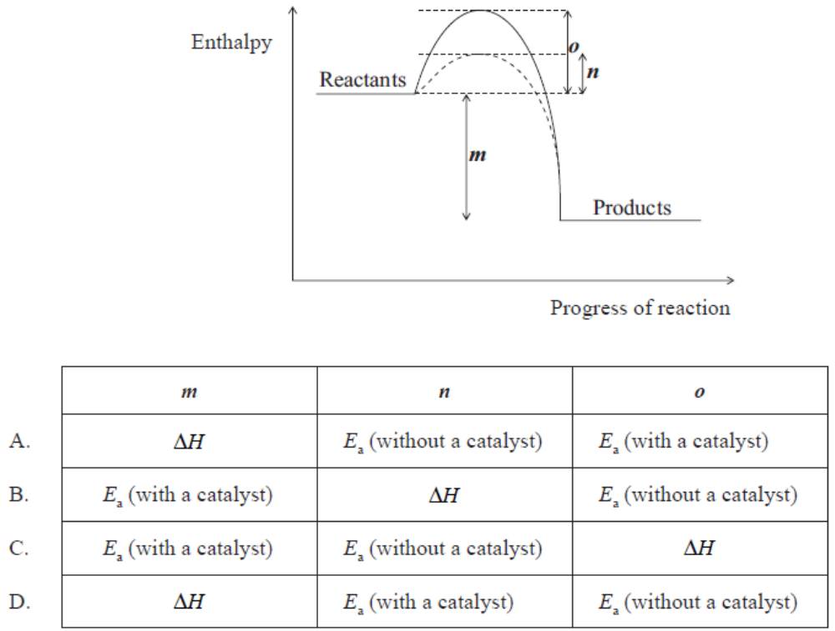
10. Under which conditions will the reaction between 1.0 g calcium carbonate and excess hydrochloric acid be the fastest? Assume that all reactions are carried out at the same temperature.
A. One large piece of calcium carbonate and 2 mol dm⁻³ hydrochloric acid
B. One large piece of calcium carbonate and 1 mol dm⁻³ hydrochloric acid
C. Powdered calcium carbonate and 2 mol dm⁻³ hydrochloric acid
D. Powdered calcium carbonate and 1 mol dm⁻³ hydrochloric acid
11. At 25℃, 200 cm³ of 1.0 mol dm⁻³ nitric acid is added to 5.0 g of magnesium powder. If the experiment is repeated using the same mass of magnesium powder, which conditions will result in the same initial reaction rate?
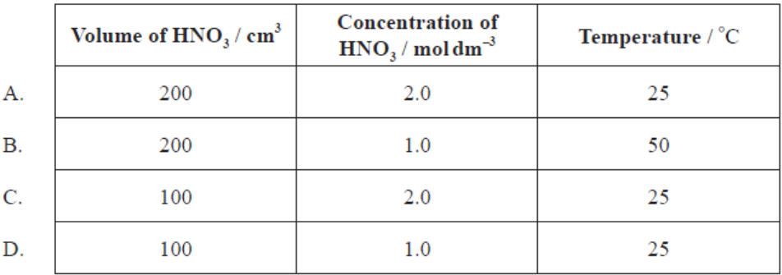
12. A student added 0.20 g of calcium carbonate powder to 100 cm³ of 1.0 mol dm⁻³ hydrochloric acid (an excess) and measured the volume of the gas that was evolved. The graph of the results is shown below.
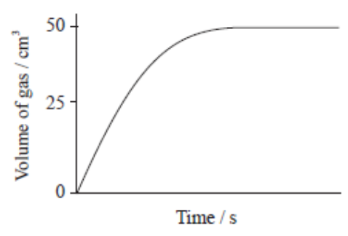
Which graph would be obtained if 0.20 g of calcium carbonate powder is added to 100 cm³ of 0.5 mol dm⁻³ hydrochloric acid?
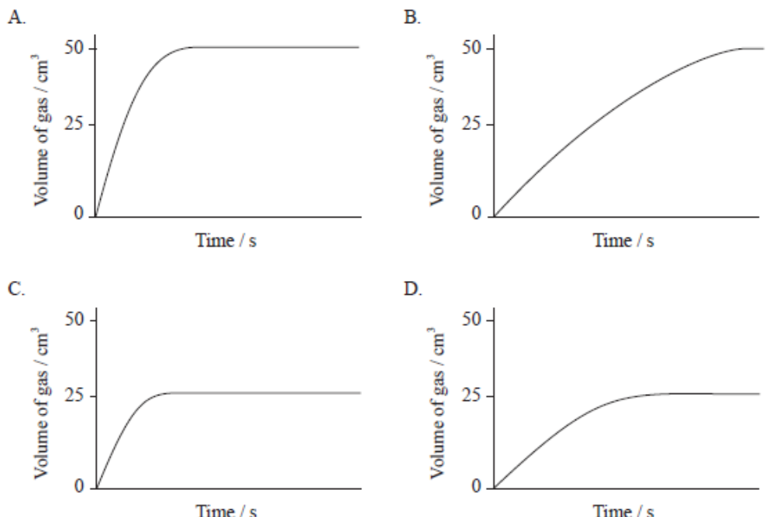
13. Which statement about the kinetic theory is not correct?
A. The particles in ice vibrate about fixed points.
B. The particles in steam have more energy than the particles in ice.
C. All the particles in water have the same amount of energy at 298 K.
D. Evaporation of water occurs at all temperatures between 273 K and 373 K when the atmospheric pressure is 101 kPa.
14. Which of the following can increase the rate of a chemical reaction?
I. Increasing the temperature
II. Adding a catalyst
III. Increasing the concentration of reactants
A. I and II only B. I and III only C. II and III only D. I, II and III
15. Powdered manganese (IV) oxide, MnO₂ (s), increases the rate of the decomposition reaction of hydrogen peroxide, H₂O₂ (aq). Which statements about MnO₂ are correct?
I. The rate is independent of the particle size of MnO₂.
II. MnO₂ provides an alternative reaction pathway for the decomposition with a lower activation energy.
III. All the MnO₂ is present after the decomposition of the hydrogen peroxide is complete.
A. I and II only B. I and III only C. II and III only D. I, II and III
16. Propanone reacts with bromine in acidic solution according to the following equation.
A student investigated the kinetics of this reaction using data logging equipment. Her data are shown below.
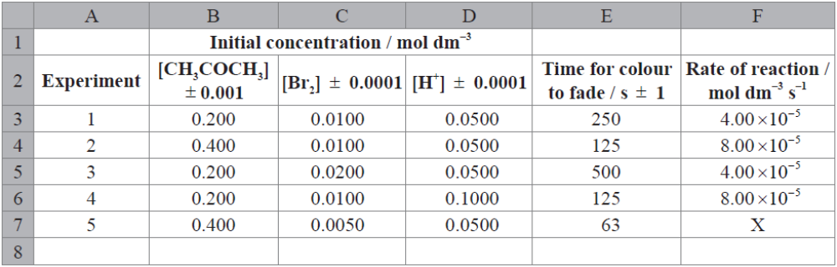
(a) (i) Identify the reagent the student used to monitor the rate of reaction. [1]
_____________________________________________________________________________________
(ii) Calculate the rate of reaction for Experiment 5 and comment on the precision of your result. [2]
____________________________________________________________________________________________________________________________________________________________________________________________________________________________________________________________________________________________________________________________________________________________________
(iii) Determine the percentage uncertainty in the calculated rate for Experiment 4. [2]
____________________________________________________________________________________________________________________________________________________________________________________________________________________________________________________________________________________________________________________________________________________________________
(b) (i) Describe how the rate of reaction changes when the concentration of CH₃COCH₃ is doubled and explain this change on a molecular level. [2]
___________________________________________________________________________________________________________________________________________________________________________________________________________________________________________________________________________
(ii) The student suggested that H⁺ acts as a catalyst in the reaction. Describe the effect of a catalyst on a chemical reaction. [1]
__________________________________________________________________________________________________________________________________________________________________________________
(iii) Comment on whether or not this hypothesis is supported, with reference to the chemical equation and the experimental data. [2]
____________________________________________________________________________________________________________________________________________________________________________________________________________________________________________________________________________________________________________________________________________________________________

17. Hydrogen peroxide, H₂O₂ (aq), releases oxygen gas, O₂ (g), as it decomposes according to the equation below.
50.0 cm³ of hydrogen peroxide solution was placed in a boiling tube, and a drop of liquid detergent was added to create a layer of bubbles on the top of the hydrogen peroxide solution as oxygen gas was released. The tube was placed in a water bath at 75℃ and the height of the bubble layer was measured every thirty seconds. A graph was plotted of the height of the bubble layer against time.
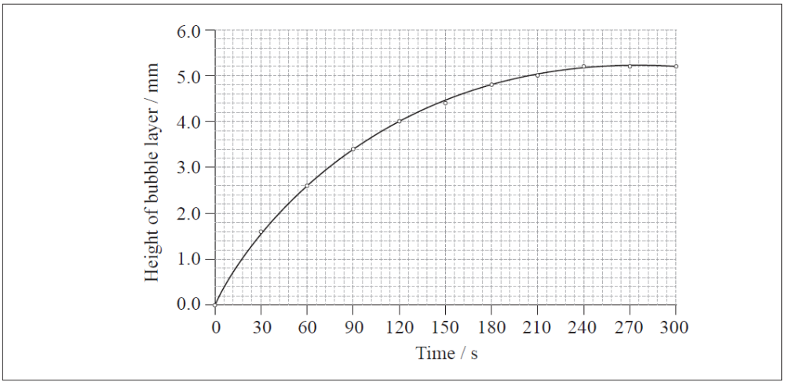
(a) Explain why the curve reaches a maximum. [1]
__________________________________________________________________________________________________________________________________________________________________________________
(b) Use the graph to calculate the rate of decomposition of hydrogen peroxide at 120 s. [3]
____________________________________________________________________________________________________________________________________________________________________________________________________________________________________________________________________________________________________________________________________________________________________
(c) The experiment was repeated using solid manganese (IV) oxide, MnO₂ (s), as a catalyst.
(i) Draw a curve on the graph above to show how the height of the bubble layer changes with time when manganese (IV) oxide is present. [1]
(ii) Explain the effect of the catalyst on the rate of decomposition of hydrogen peroxide. [2]
____________________________________________________________________________________________________________________________________________________________________________________________________________________________________________________________________________________________________________________________________________________________________

18. (a) The standard enthalpy change of three combustion reactions are given below.
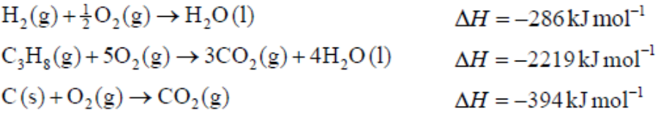

Determine the change in enthalpy, ΔH, in kJ mol^{–1}, for the formation of propane in the following reaction.
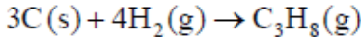 [4]
______________________________________________________________________________________________________________________________________________________________________________________________________________________________________________________________________________________________________________________________________________________________________________________________________________________________________________________________________________________________________________________________________________________
(b) A catalyst provides an alternative pathway for a reaction, lowering the activation energy, Ea. Define the term activation energy, Ea. [1]
___________________________________________________________________________________________________________________________________________________________________________________________________________________________________________________________________________
(c) Sketch two Maxwell–Boltzmann energy distribution curves for a fixed amount of gas at two different temperatures, T₁ and T₂ (T₂ > T₁) and label both axes. [3]
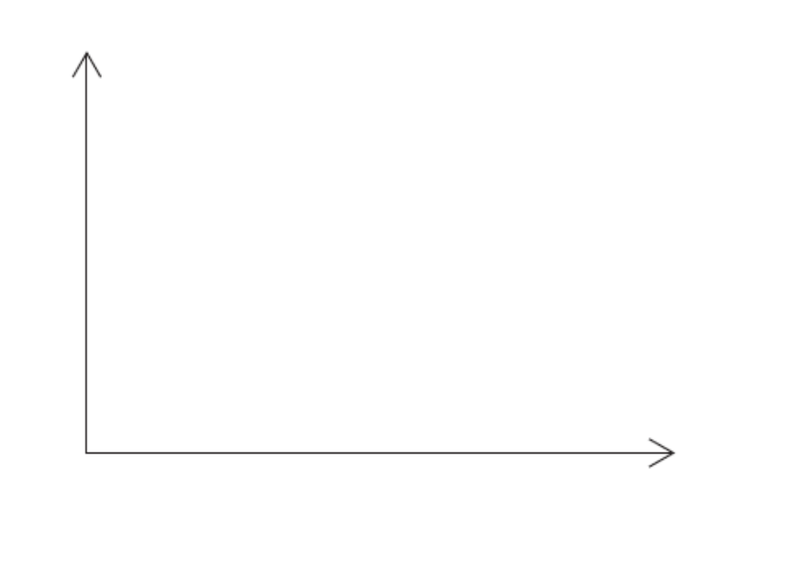
19. Factors that affect the rate of a chemical reaction include particle size, concentration of reactants and the temperature of the reaction.
(a) Define the term rate of a chemical reaction. [1]
___________________________________________________________________________________________________________________________________________________________________________________________________________________________________________________________________________
(b) List the three characteristic properties of reactant particles which affect the rate of reaction as described by the collision theory. [3]
__________________________________________________________________________________________________________________________________________________________________________________
(c) On the axes below sketch two Maxwell-Boltzmann energy distribution curves for the same sample of gas, one at a temperature T and another at a higher temperature T′. Label both axes. Explain why raising the temperature increases the rate of a chemical reaction. [5]

____________________________________________________________________________________________________________________________________________________________________________________________________________________________________________________________________________________________________________________________________________________________________
(d) Explain why coal dust burns much faster than a large piece of coal with the same mass. [1]
__________________________________________________________________________________________________________________________________________________________________________________

20. Alex and Hannah were asked to investigate the kinetics involved in the iodination of propanone.
They were given the following equation by their teacher.
Alex’s hypothesis was that the rate will be affected by changing the concentrations of the propanone and the iodine, as the reaction can happen without a catalyst. Hannah’s hypothesis was that as the catalyst is involved in the reaction, the concentrations of the propanone, iodine and the hydrogen ions will all affect the rate.
They carried out several experiments varying the concentration of one of the reactants or the catalyst whilst keeping other concentrations and conditions the same. Their results are shown graphically below.
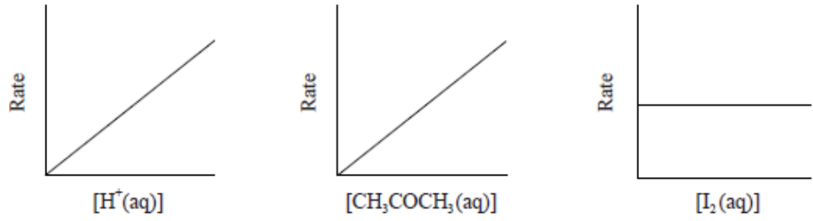
(a) Discuss whether either Alex’s or Hannah’s hypothesis is correct. [2]
____________________________________________________________________________________________________________________________________________________________________________________________________________________________________________________________________________________________________________________________________________________________________
(b) Explain why the reaction rate will increase with increasing temperature. [2]
____________________________________________________________________________________________________________________________________________________________________________________________________________________________________________________________________________________________________________________________________________________________________
(c) (i) This reaction uses a catalyst. Sketch and annotate the Maxwell-Boltzmann energy distribution curve for a reaction with and without a catalyst on labelled axes below. [3]

(ii) Describe how a catalyst works. [1]
__________________________________________________________________________________________________________________________________________________________________________________

Answers
1-5 A A D A B
6-10 A B A D C
11-15 D B C D C
16.
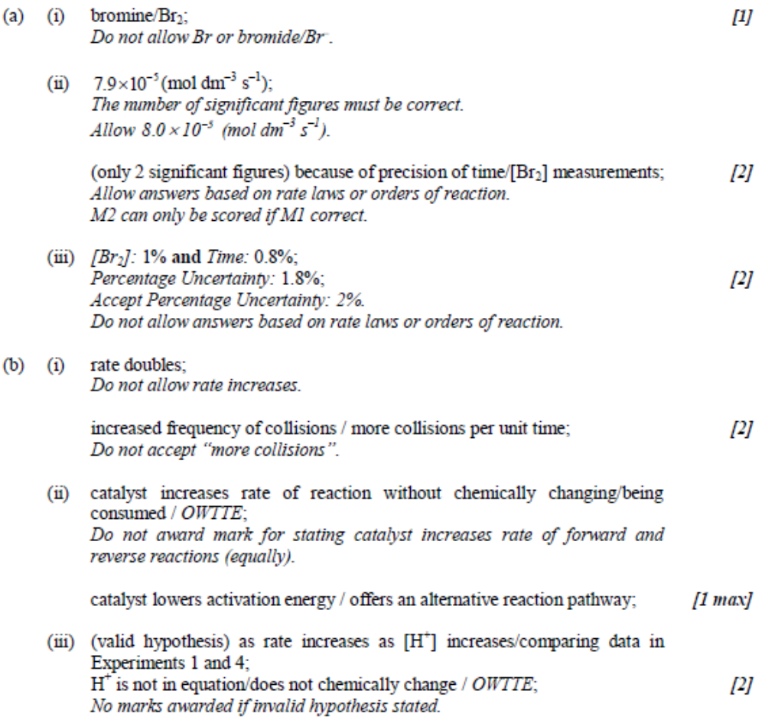
17. (a) Reaction is complete / all hydrogen peroxide/reactant is used up / no more bubbles are being produced / layer of bubbles is constant / OWTTE; [1]
(b) Correctly drawn tangent to the graph at 120 s;
Rate = gradient of the tangent to the graph at 120 s / rate= (6.0-2.0) / (240-0)
= 0.017 mm s⁻¹
Accept answers in the range 0.014 to 0.020 mm s^{–1}.
Units required for M3.
(c) (i) any line which shows the height of the bubbles increasing much faster; [1]
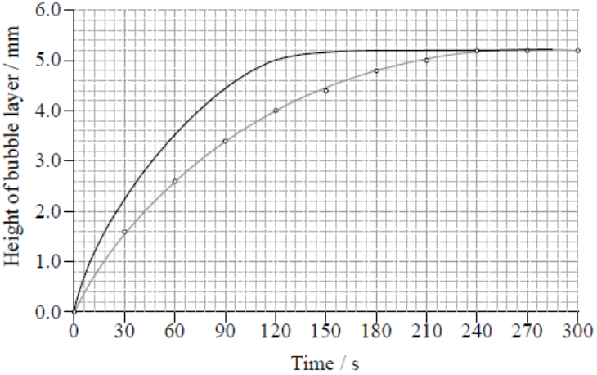
(ii) Catalyst provides an alternative reaction pathway/mechanism with a lower activation energy;
More molecules/particles have energy greater than or equal to the activation energy / OWTTE; [2]
Accept alternative response which refers to mechanism of heterogeneous catalysts.
18.
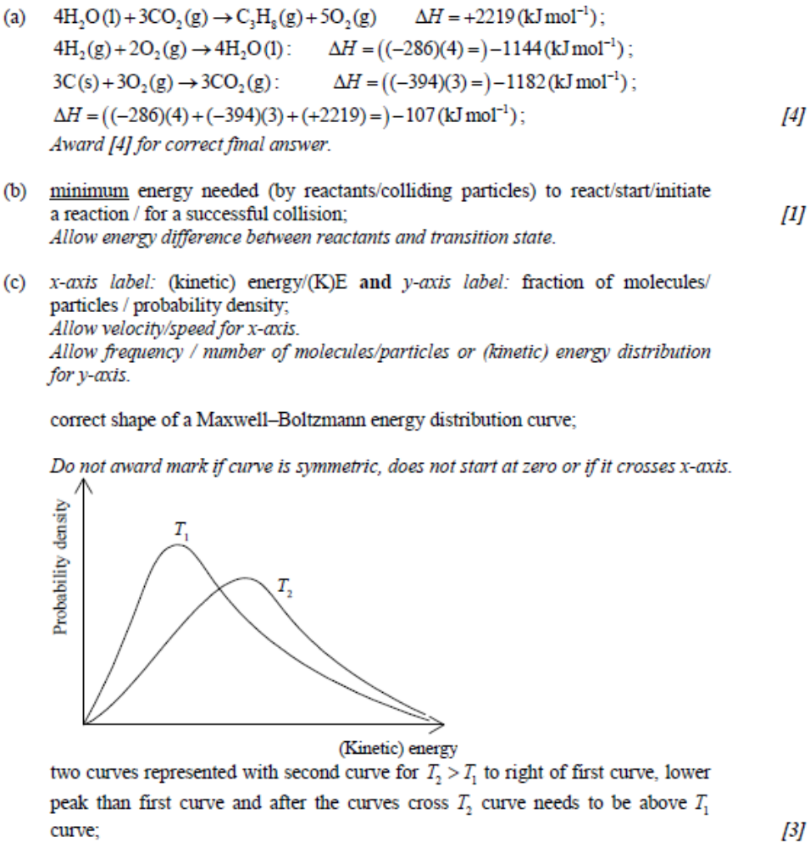
19. (a) increase in concentration of product per unit time / decrease in concentration of reactant per unit time; [1]
Accept change instead of increase/decrease and mass/amount/volume instead of concentration.
(b) frequency of collisions;
kinetic energy/speed of reactant particles;
collision geometry/orientation; [3]
(c)
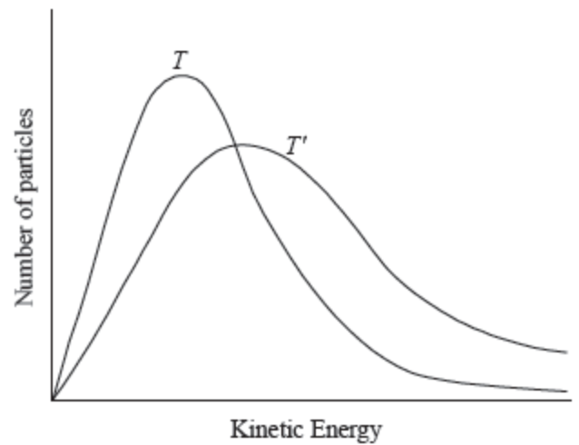
correctly labelled axes showing number of particles/frequency against (kinetic) energy;
correctly shaped graph for T (curve must not touch or cross x axes);
T′curve to the right of T and with a peak lower than T;
increasing the temperature increases the (kinetic) energy of the particles / more particles will possess the necessary activation energy;
there will be more collisions per unit time / the frequency of collisions increases / there are more successful collisions; [5]
(d) the dust has a greatly increased surface area / more of the coal can come into contact with the oxygen molecules when it is in dust form / OWTTE; [1]
20.
